1C - Financial – Lesson 1
Taxation – TFN & Allowable Deductions

Name: _________________

- What is a TFN and what do the letters mean ?

- Check to see if the TFN’s are valid.

  - 983 543 678
_ _ _ _ _ _ _ _ _
x x x x x x x x x
1 4 3 7 5 8 6 9 10
= = = = = = = = =
_ + _ + _ + _ + _ + _ + _ + _ + _ = ___

____ ÷ 11 = ____ Divisible by 11?? T/F

  - 978 343 123

  - Your TFN: _ _ _ _ _ _ _ _ _

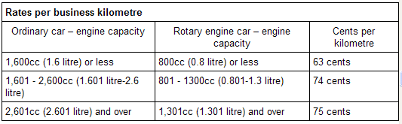
- Calculate the Claim for:
  - A 600cc rotary engine for 6700 km.

Claim = 6700 km x $0.__

= $ ______

  - An ordinary 3 litre car traveling for 6900 kilomtres.

Claim = ______ km x $_.__

= $ ______

- John buys a luxury for $47,000. Since he did over 5,000 km he decided to claim 12% of the value as a deduction. How much can he claim?

Claim = 0.12 x $47,000 = $ ________

- Mary decides to the same on a $200,000 car. Unfortunately the limit for this year is $57,180.

Claim = ____ x $57,180 = $______

- Bill decided to claim 1/3 of all his petrol, oil and maintenance costs. They were $15,000. How much can he claim?

Claim = 1 ÷ 3 x $ ________ = $ ________

- Sam has a similar business to Bill but his total non capital costs were $27,000. How much can she claim?

Claim =

- What is the other method of claiming work-related car expences?

L _ g b _ _ k.

